***Documentation***

**Title: Software Freedom Kosova 16**

**Project description:**

Organized by FLOSSK, the seventh annual Software Freedom Kosova conference was a major technology event focusing on free and open-source software. SFK16 featured 43 speakers from 18 countries, offering 48 lectures and workshops over three days. The event included a main presentation day and two additional days of hands-on workshops held at ICK and Prishtina Hackerspace. The conference provided a platform for participants to engage with influential tech figures, develop technical skills, and generate new ideas.

**Activities:**Key activities:

* Held 17 hours of programming across 48 sessions
* Organized 8 project demonstration tables
* Conducted workshops at ICK, RIT Kosovo, and Prishtina Hackerspace
* Featured international and local expert speakers

**Photos:**

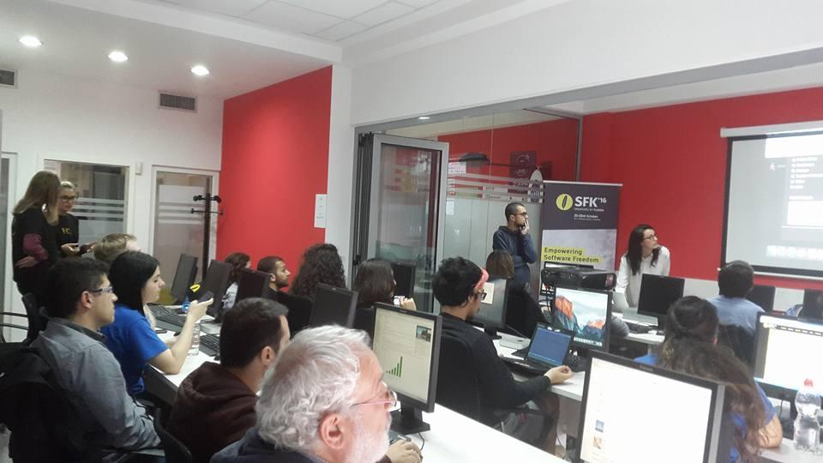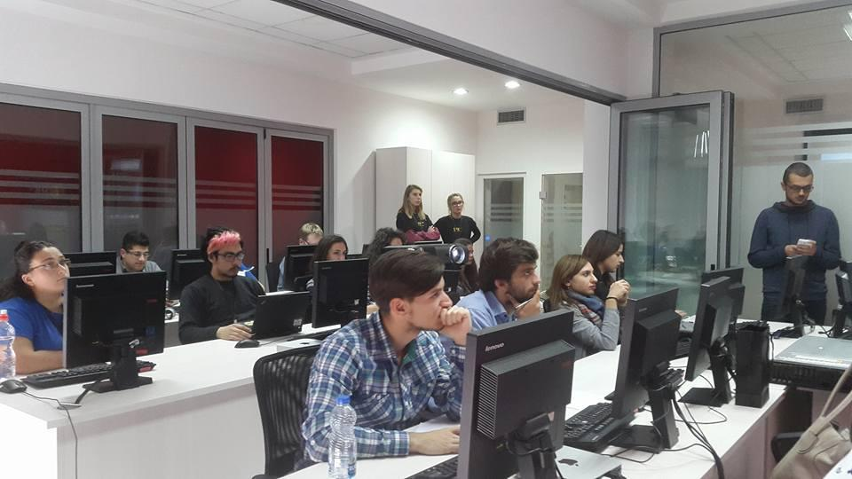

**Beneficiaries:**

The beneficiaries of SFK16 included technology enthusiasts, students, and professionals from Kosovo and abroad. The conference helped foster a broader understanding of free and open-source software, supported the development of local talent, and facilitated networking between local businesses, global speakers, and participants.

**Partners:**

* Ministry of Education, Science, and Technology (MASHT)
* Innovation Center Kosovo (ICK)
* Prishtina Hackerspace

**Budget:  
€2,012.50**

**Project duration**:

October 21-23, 2016

*This document is FLOSSK intellectual property - Do not share without authorization from FLOSSK.*